CAFÉ MANAGEMENT SYSTEM
A project submitted to
UKA TARSADIA UNIVERSITY
in partial fulfilment of the requirements for the degree of

Bachelor of Science in Information Technology
For
5 Years Integrated M.Sc.(IT)
For 5th Semester
By
Vishwa Chaturvedi
(201806100110127)

Guided by
Mrs. Preeti bhat
Assistant Professor



CERTIFICATE
This is to certify that VISHWA CHATURVEDI (201806100110127) has submitted project entitled
“CAFÉ MANAGEMENT SYSTEM” as the partial fulfillment for the award of the degree of Bachelor of Science in
Information Technology for 5 Years Integrated M.Sc.(IT) in 2020 – 2021.
Date:

&lt;&lt;Guide Name&gt; &gt; Dr. Jitendra Nasriwala
Guide Programme Coordinator,

.

External Examiner
Subject Teacher

AKNOWLEDGEMENT

WE WOULD LIKE TO EXPRESS OUR SPECIAL THANKS OF GRATITUDE TO OUR SOFTWARE ENGINEERING SIR “MR. BHAVIKSARANG” FOR THEIR ABLE GUIDANCE AND SUPPORT TO COMPLETING MY PROJECT.
WE WOULD LIKE TO EXTEND OUR GRATITUDE TO OUR HEAD OF DEPARTMENT SIR “MR. JITENDRA NASRIWALA” FOR PROVING US WITH ALL THE FACILITY THAT WAS REQUIRED.

Table of Content
Chapters | Particulars |  |  | Page no.
1 | Introduction
1 | 1.1 | Purpose
1 | 1.2 | Product Scope
1 | 1.3 | Problem Definition
2 | Overall Description
2 | 2.1 | Product Perspective/ Environment Description
2 |  | 2.1.1 | Hardware Interface/ Hardware Specification
2 |  | 2.1.2 | Software Interface/ Software Specification
2 |  | 2.1.3 | Communication Interface
2 | 2.2 | User Characteristics
3 | System Planning
3 | 3.1 | Software Engineering Model
4 | System Specific Requirements
4 | 4.1 | Functional Requirement
4 | 4.2 | Non-functional Requirement
5 | System Analysis
5 | 5.1 | Use case Diagram(s)
5 | 5.2 | Activity Diagrams
5 | 5.3 | Sequence Diagrams
6 | System Design
6 | 6.1 | Database Design
6 | 6.1 | 6.1.1 | Database Schema
6 | 6.1 | 6.1.2 | Data Dictionary
7 | System Implementation
7 | 7.1 | Screenshots
8 | Testing
8 | 8.1 | Test Cases
9 | Future Enhancement
 | Conclusion
 | Bibliography

List of Figures
Figure no. | Figure Description | Page no.
5.1.1 | Use Case Diagram for Admin
5.1.2
5.1.3
5.2.1 | Activity Diagram for Manage Product
5.2.2
5.2.3
5.2.4
5.2.5
5.3.1 | Sequence Diagram for “adding a product”

Initial requirements
Title of Project | Café Management System
Stakeholders | Admin, employees, customer
Techniques used for requirements capturing | Interviewing and Questionnaire
Name of the persons along with designation | -
Date | April, 2020
Version | 1.0
Consolidated list of Initial Requirements
- Is there any problem with your traditional system?
- What is your objective?
- What is your budget?
- Who will be using the system?
- You want an online system or a desktop system?
- How many staff members do you have?
- How many tables do you manage?
- Do you want the order to be displayed to the chefs in the kitchen?
- Will you provide some special offers to the customer and your members on festive and other occasion?
- What will be the duration of membership if you want ?
- Which type of payment method you will prefer?
- To whom you want the customers and order details should be viewed ?
- Do you want to get notified by the system when you inventory is about to finish?
- Do you want the system to generate the employee report with their working hours and standard of working?
- Will you allow the customers to give feedback and their reviews?

- What details you want the system to store about the staff, the customers and the inventory of the café?
- List out the problems that you have with the old system.
- Why you want to create this café management system?
- Do you want a cash memo to be generated at the end of transaction and why?
- What other functional requirements you want to add that you think will improve the system and uniqueness?

Introduction:
This document is intended for different type of readers such as café owner, the system designer, the system developer and the tester. By reading this document a reader can learn about what the project is implemented for and how it will present it’s basic idea. This document has a sequential overview of the whole project so if a reader reads the document from top to bottom , he / she will get a clear idea about the project.

PURPOSE
This document gives a detailed description of the objectives, features, user-interface and application of the “café management system” in real life. It will also describe about the working of system and under which it must operate. User interface will be shown in this document. Both the user and the developers of the system will be benefited from this document.
Designed to make the existing system more informative, reliable, fast and easy for both the users.
SCOPE
This system will help to manage and run the café business systematically. In this management system we will provide an app that can be used by the owner to manage the orders and serve their customer and also by the customers to make online orders and payments.
Where the employee (waiters) of the café will take order and the order is shown in both owner’s screen and the kitchen where the order is to be made by chef. The customers can also give the feedback through this app so that the owner can evaluate accordingly. The customers can also make payments through debit and credit cards or online. All the information about the daily expenses and profit will be saved in the system for the owner. Also the required information about the employees will be saved in the system which can be accessed only by the system admin.
The system is useful to: ADMIN, OWNER, WAITERS, CHEFS, CUSTOMERS (JUST FOR FEEDBACK).

PROBLEM DEFINITION
Managing the café and all its orders and payments with special offers and discounts is so unorganized when you tend to do it manually. So basically there is a vast need to organize their paperwork and accounting system. The existing method is highly manual involving a lot of paper work and calculation and this led to inconsistency and inaccuracy in the maintenance of the data .The data which is stored on the paper may be lost, stole or destroyed due to natural calamity.
To make this task easy we propose a “CAFÉ MANAGEMENT SYSTEM”. This will eliminate all the traditional (manual) way of managing a café and provide an ease in managing all the tasks of café being done satisfyingly thorough the system and it also facilitates customers to give order from home which saves time and provide ease to customers.
- An admin will be able to modify menu by entering product names and price and also the special offers.
- The system will display a description, price and list of items.
- The system will allow to make payment by cash/card/online.
- Order details for food items will be printed including the quantity, item name and price.
- The system will allow online ordering and payment method.
Overall Description:

PRODUCT PERSPECTIVE
The café Management shall be developed using client/server architecture and compatible with Microsoft Windows Operating System .The front-end of the System will developed using visual studio 2010/2019 and the back-end will developed using Ms SQL Server 2008.
Back-end Database

Front-end client application (maintain stock, sales calculation)

HARDWARE INTERFACES
- Screen resolution of at least 640 * 480 or above.
b) Computer system will be in the networked environment as it is a multi-user system.

SOFTWARE INTERFACES
- MS-Windows Operating System.
- Microsoft Visual Studio 2010 for designing front-end.
- Ms SQL server 2008 for back-end.

COMMUNICATION INTERFACES
Communication is via local area network (LAN).

USER CHARACTERISTICS
- Admin or the owner
- The main person in the cafeteria who is having all the rights to access the system and view all the information whether it is about the customer, the employee, the goods needed, the
goods available and the feedback given by the customers. The one who is responsible for establishing and maintaining daily menus/offers(if any). And the admin also needs to edit the café’s menu periodically.

- Cafeteria staff
- Which includes :
- the waiters
- the chefs
- the process will impact café’s 20 employs including both the waiters and the chefs ,
- Waiters:- who will receive / take the order from the customers through the tablets(installed our system) send it to the chefs to indicate the making of order. They will also make sure of order being served by checking the “order served” option. Will make a bill and send a copy of this to the owner’s pc and complete the process.

- Chefs:- who will receive the item name to be made and and will also give the updates to the waiters for order being made and ready for serving.
- MOST OF THE CAFETERIA STAFF WILL HAVE TO BE TRAINED FOR THE USE OF SYSTEM .

- CUSTOMER
- Customer is also the user of this system as they will be using it for the feedback purpose which they will be giving in the tablets itself.

System Planning:
SOFTWARE ENGINEERING MODEL
Waterfall Model
We have followed this model step is…
- Requirement Analysis
- Design
- ** Analysis **
- Implementation
- Unit Testing
- Integration And Testing
- Deployment And Maintenance
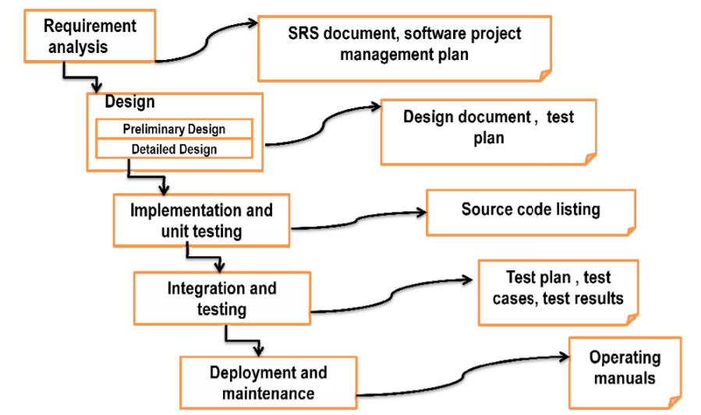
- The waterfall model begins with the system. It gathers requirements from the customer. At the end SRS and software project plan are produced. The SRS acts as a contract between the customer and the developer.
- In the design phase, the SRS is transformed into design which is suitable for implementation in a programming language.
- First preliminary design is made then detailed design is m initial test plan are produced at the end of this phase
- During the implementation phase.
- In unit testing small modules are tested in isolation and the overhead code is written for handling communication amongst these modules.
- After implementation and unit testing, the modules are integrated to form a complete system. Integration and testing are carried out to verify the functionality of the system.
- After proper testing the software is, test phase and test results are outputs in this phase.

System Specific Requirements:
FUNCTIONAL REQUIREMENT
- Registration:
    - The customer and the employees (waiters, chef, delivery boy ) shall be able to register with their details. The system must record the following details for the customer and the employee separately:
              - Name(username)
              - Email
              - Password
              - Address
              - DOB
              - Gender

- Login:
    - Separate login is maintained for each user. Administrator, chef, waiter, delivery boy and customer will be authenticated with their username and password to login into the system.
    - After logging in the members should be directed to home screen.
- Manage staff details:
    - The admin shall be able to view number to employees who is working in café and all their details which they entered during registration. As well as admin would be able to know who joined and who left.
    - The system shall be able to allow staff members to change their password and make update in their details like address etc.
    - Managing staff salary.
    - Admin can search employee details.
- Manage customer details:
    - The system will allow admin to view customer details like name, dob, address, etc. which are added at the time of registration.
    - Order history of particular customer.
- Search items by category:
    - The system will allow the customers to search items by categories to place order.
- Managing café items and related information:
    - The will allow admin to add new items , delete some if necessary, edit pricing, new category.
    - Manage special offers or discounts on items during festivals.
- Managing orders:
    - Record table wise orders.
    - Status of order(preparing/made/served)
    - Record online orders.
    - Allocating it to delivery boys
    - Status of delivery of order.
- Bill generation:
    - Due billing for each order made by customer table wise.
    - The system shall be able to generate Random invoice id.
    - Fetch the ordered items from list, quantity ,apply tax involved and give discounts if any available
    - System will be generating final bill and display it to customers .

- Payment details:
    - System will allow cash , credit card , other payment gateway
    - System will keep record of payments made by customers and the mode of payment.

- Report:
  - Bill report/income report
  - Order report
  - Employee report
  - Customer feedback report
  - Delivery report

NON-FUNCTIONAL REQUIREMENT
- Requires large database.
- Security
- Availability
- Employees never allowed updating their salary information.
- System shall be available during normal café operation system.
- Can be access by anywhere.
- Discount coupons available.
- Different payment mode will be provided to customer.
- Staff members will never be able to update the product information in the menu.

System Analysis

Use case Diagram
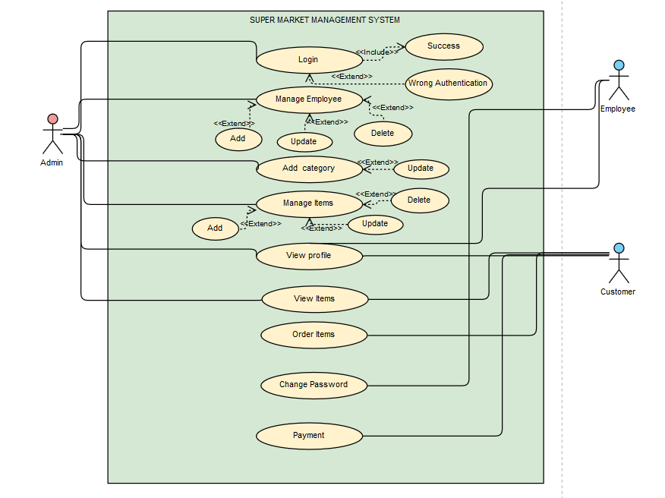
Café management system

Activity Diagram
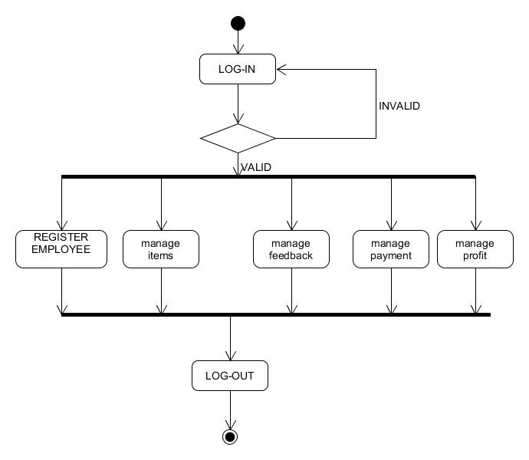

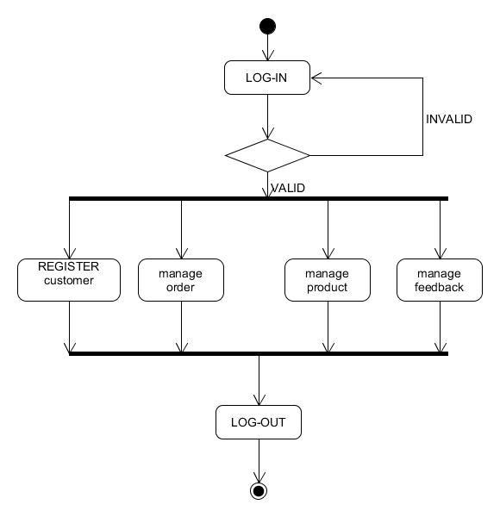

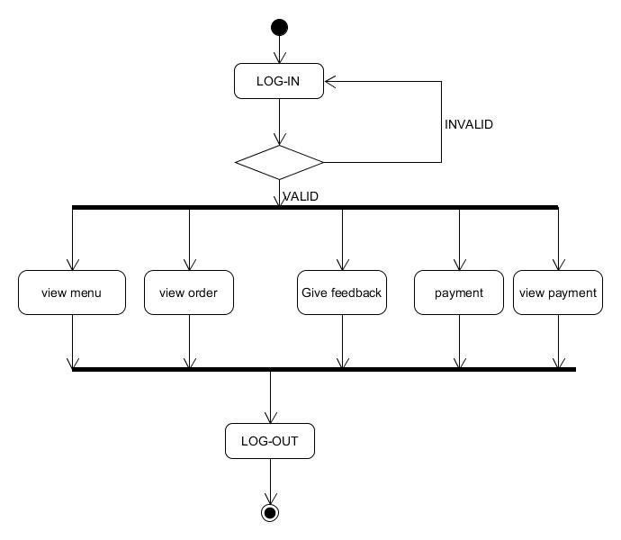

Sequence Diagram
Login sequence diagram:-
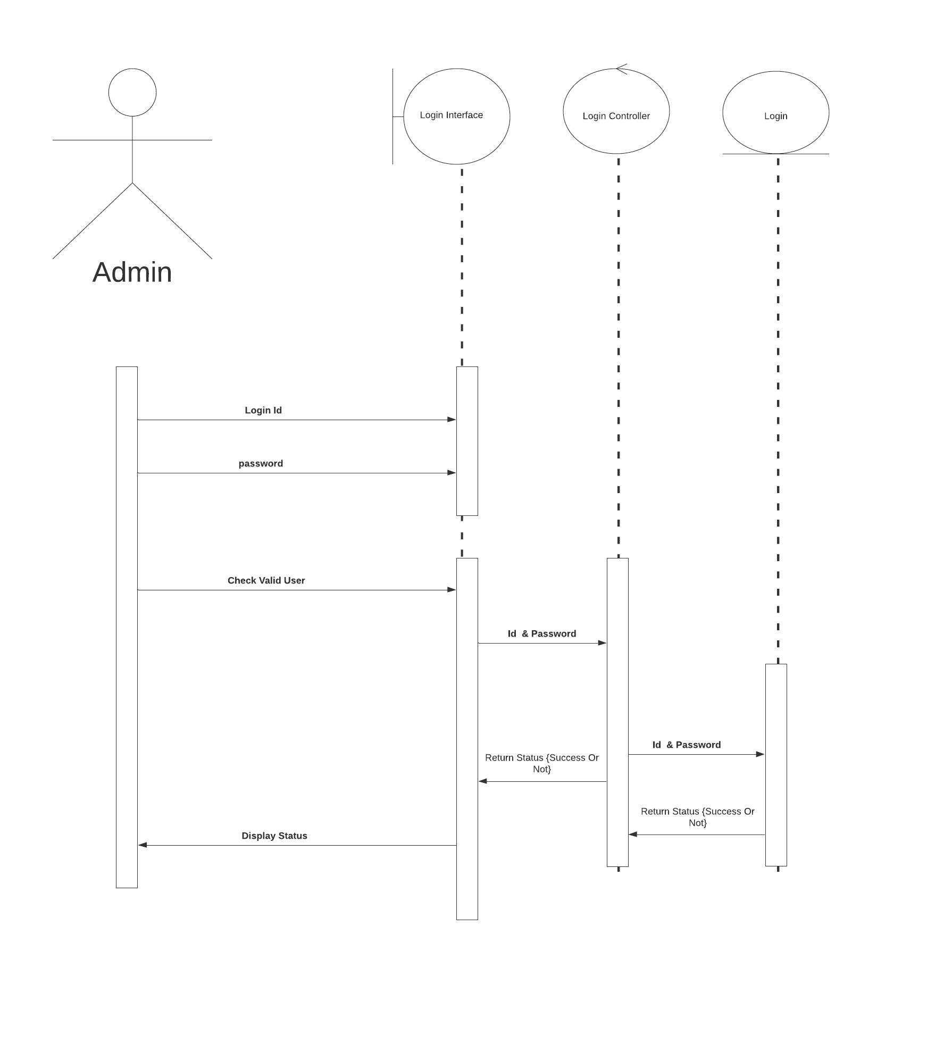

Manage menu: Admin:-
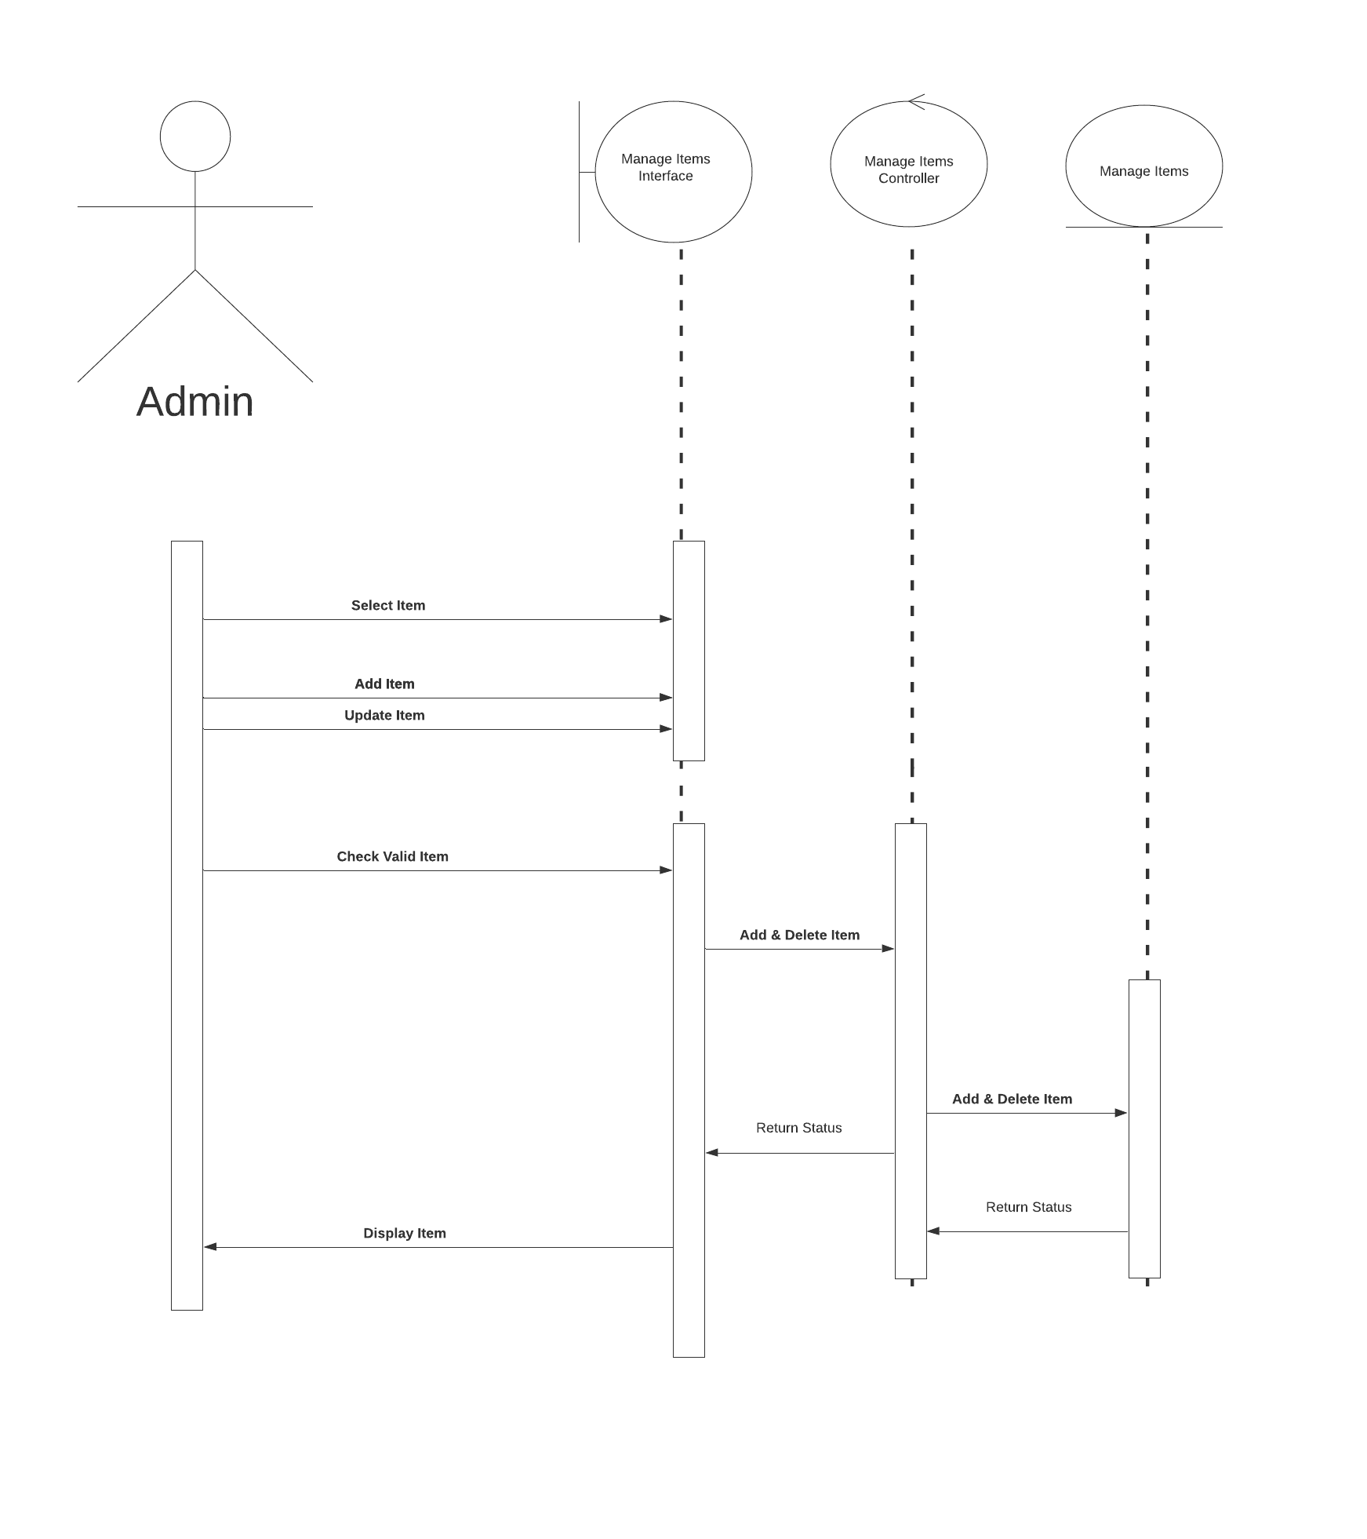

Make order: Customer:-

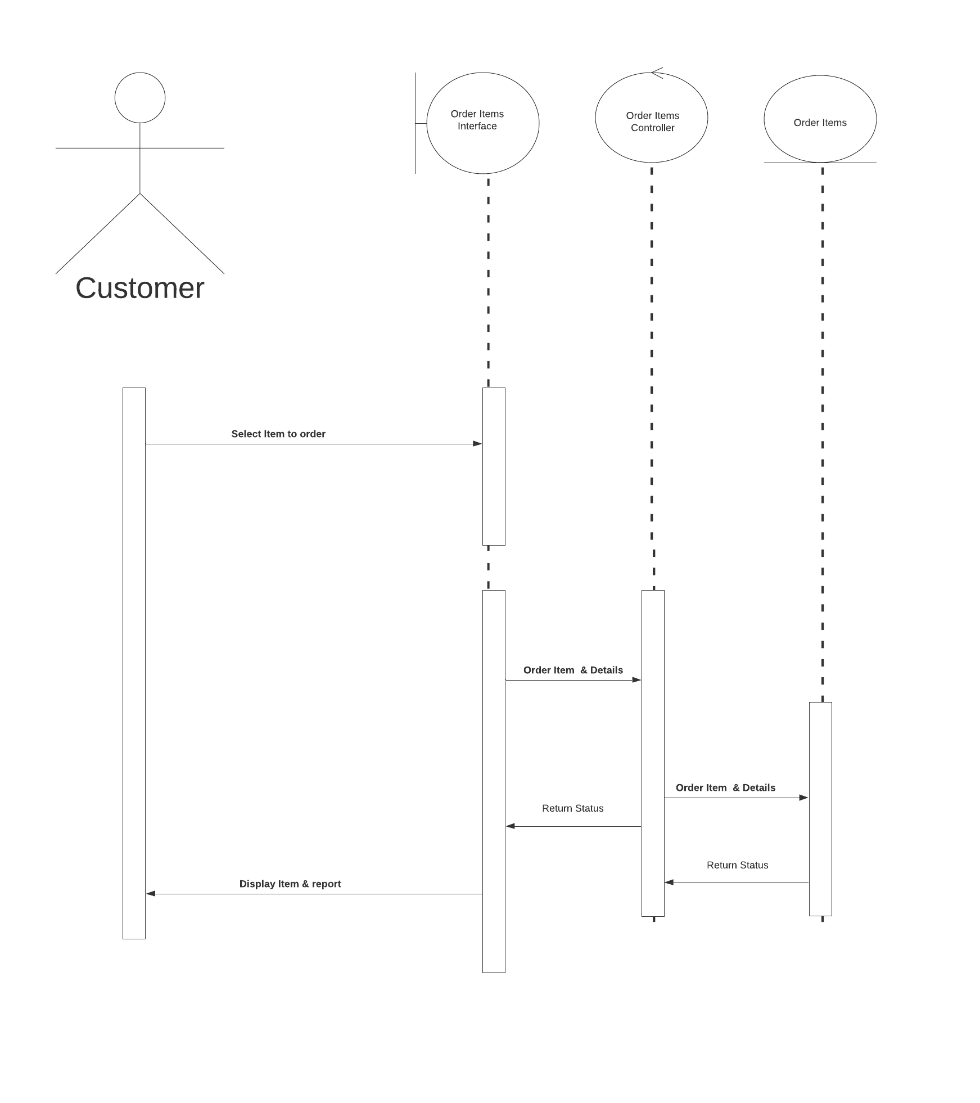

Generate bill to the customer:-
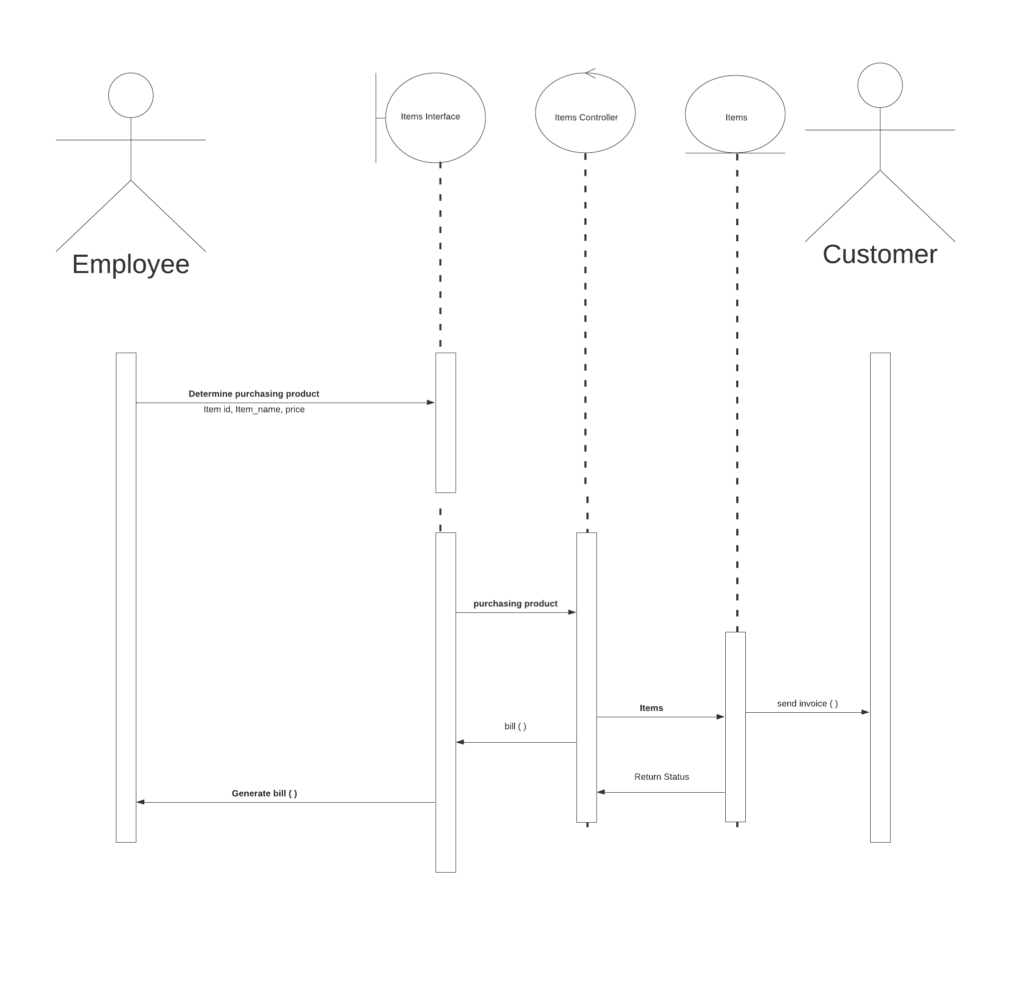

System Design
Database Design

Symbol of key=Primary key
Symbol of key with star=primary key with auto_increment

II) Data Dictionary:
Login
Filed | Type | Key | Description
Username | Varchar(255) | Unique
Password | Varchar(255)
Login | Varchar(255)

Admin
Filed | Type | Key | Description
Username | Varchar(255) | Foreign | With Class Login
Password | Varchar(255)
Login | Varchar(255)
Manage Items | Varchar(255)
View Profile | Varchar(255)
View Items | Varchar(255) | Foreign | With View table Item Id

Stewards
Filed | Type | Key | Description
S_id | Int | Primary | auto_increment
Username | Varchar(255) | Foreign | With Class Login
Password | Varchar(255)
Login | Varchar(255)
Email | Varchar(255) | Unique
Gender | Varchar(255)
Phone | Varchar(255)

Customer
Filed | Type | Key | Description
Customer_id | Int | Primary  Foreign | auto_increment  With Payment table
Username | Varchar(255) | Foreign | With Class Login table
Password | Varchar(255)
Login | Varchar(255)
Address | Varchar(255)
Email | Varchar(255) | Unique
Gender | Varchar(255)
Phone | Varchar(255)
View Items | Varchar(255)
Order Details | Varchar(255)
Payment | Varchar(255)

Orders
Filed | Type | Key | Description
Item_id | Int | Primary | auto_increment
Item_name | Varchar(255)
Order | Varchar(255) | Foreign | With Customer Table
Cost | Varchar(255)
Quantity | Varchar(255)
Picture | Varchar(255)
Item_Description | Varchar(255)
Customer_id | Int

Payment
Filed | Type | Key | Description
Customer_id | Int | Primary | auto_increment
Payment Date | Date
Amount | Int | Foreign | With Customer Table

System Implementation
Screenshots

Admin Login
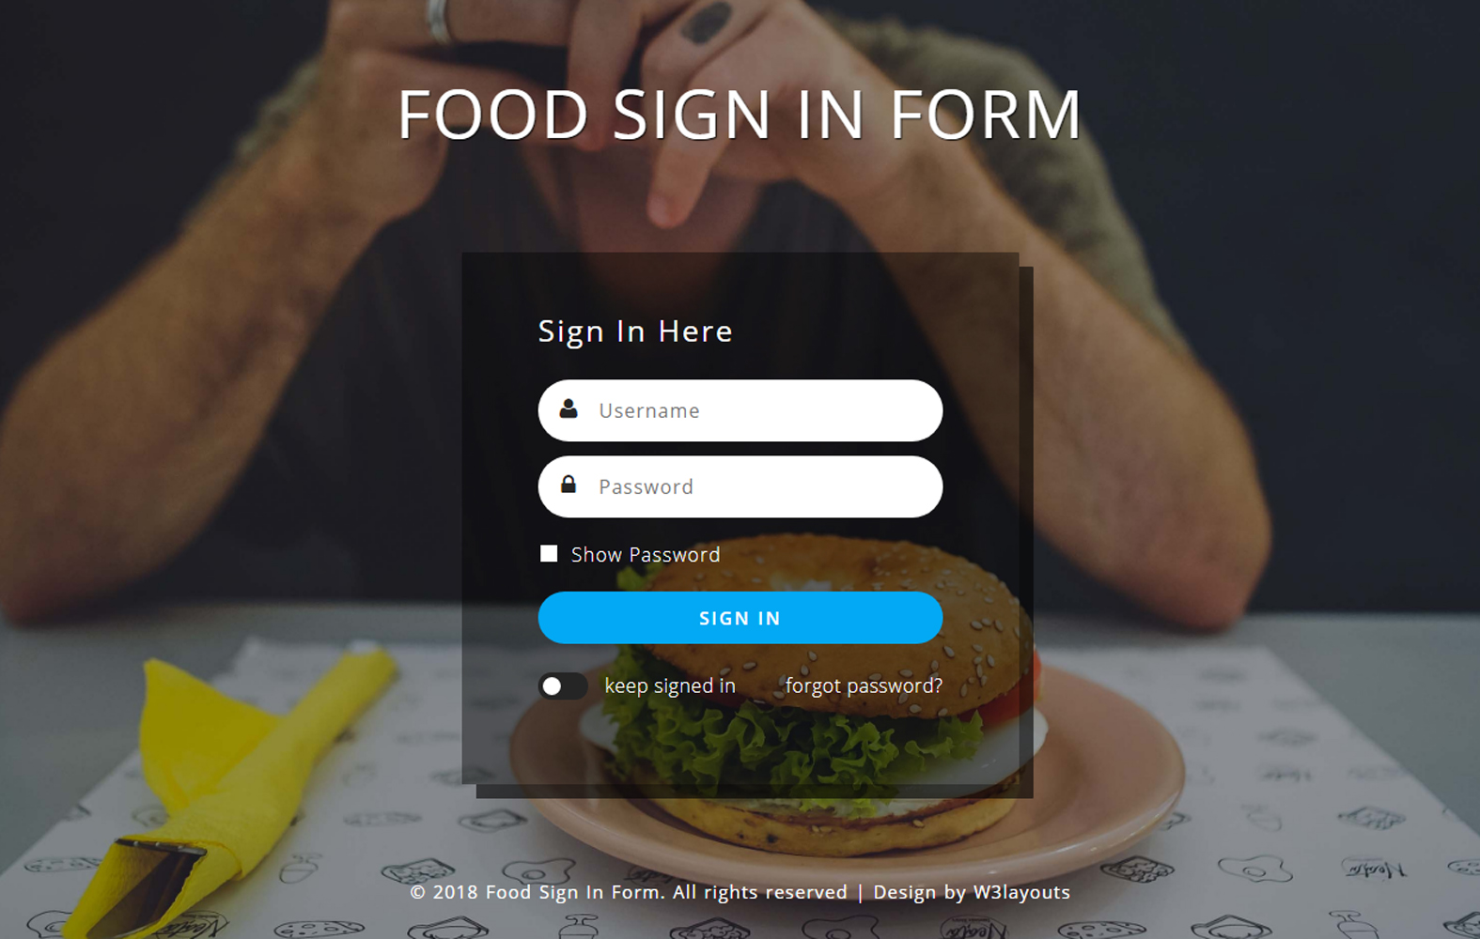
- Password protection encryption

Menu
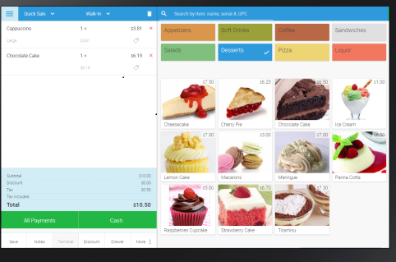

Feedback form
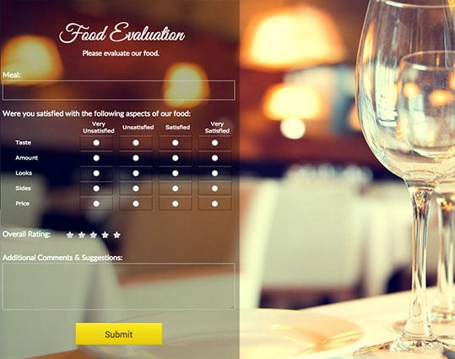

Conclusion
  - This system provides an easy way for the operator to interact with database and manipulate the data in the database.
  - The operator can add, delete, update and search records in the database with ease.
  - This system will lead to paperless society and manage all the data.
  - It provide easy, accurate, unambiguous and faster data access.
  - This project is therefore, designed in order to minimize the day to day problem.

BIPLIOGRAPHY

BOOK REFERRED: • Book Name: object oriented software engineering •
Author Name: Yogesh Singh, Ruchika Malhotra

Site Reffered :- www.w3school.com  

